Interface Screenshot guide

Step 1 – First choose the model in sidebar

Step 2 – Write a keyword in input section e.g.: Openai or Google

Step 3 – Click on analyze

Step 4 – Same for other models to analyze

In this screenshot I have used VADER model you can use any model to analyze

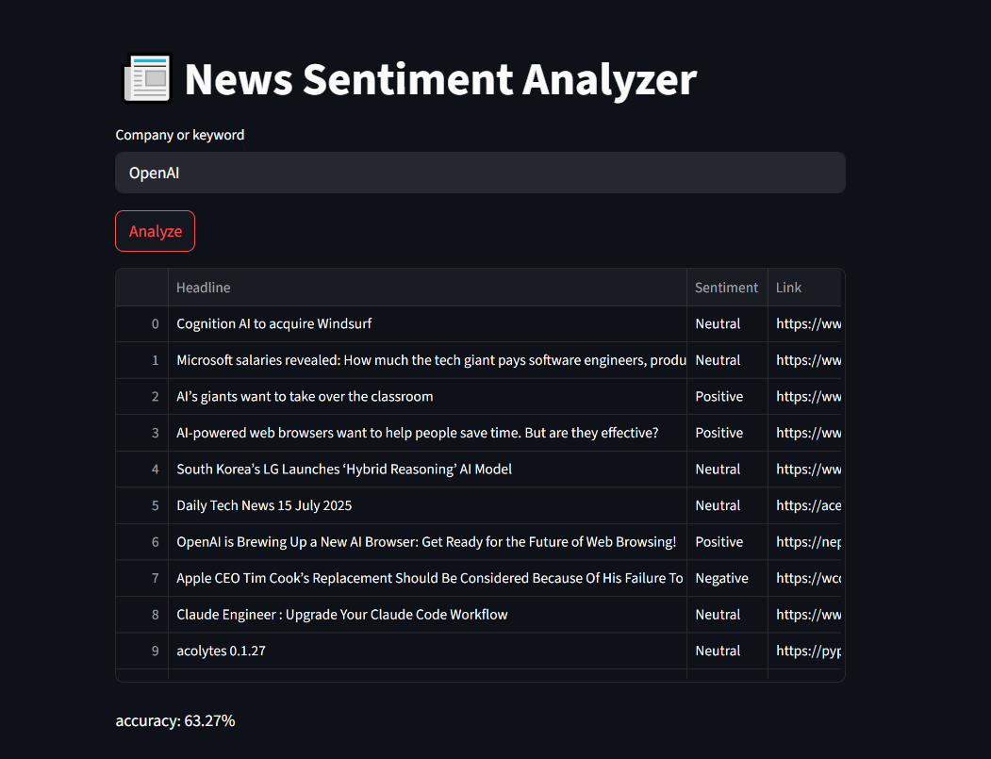

The above screenshot shows news sentiments like is it neutral, positive or negative and also the model accuracy

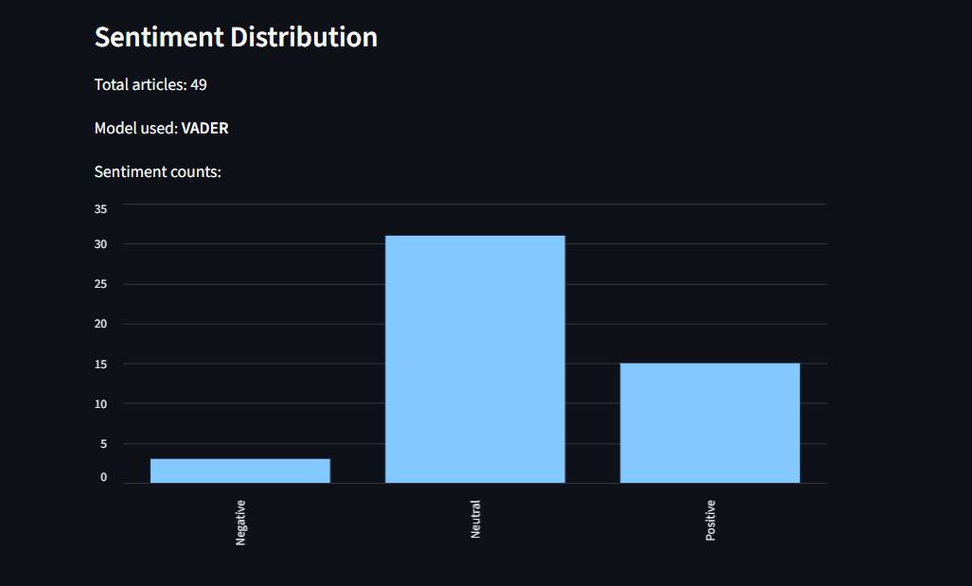

The above screenshot shows output chart for total sentiments , model name and total articles

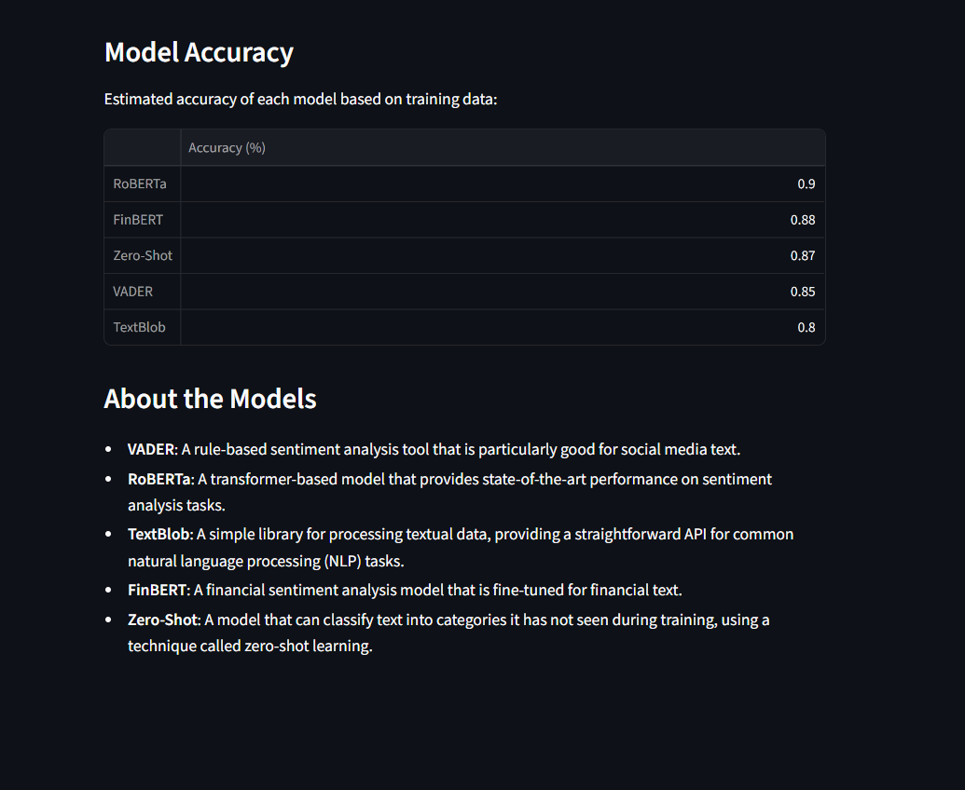

The above screenshot shows model accuracy comparisons and information about the models (VADER,ROBERTA,TEXTBLOB,FINBERT,ZERO-SHOT)